How to use the Datascape?

Main contributor:  Matthias Lois with comments from Florence Perret and Guillaume Daudin

The Toflit18 Datascape is a useful tool for exploring the collected data on the French foreign trade during the 18th century. It has several features and the aim of that documentation is to display all the functions and possibilities offered by that device.

The user interface of the home page

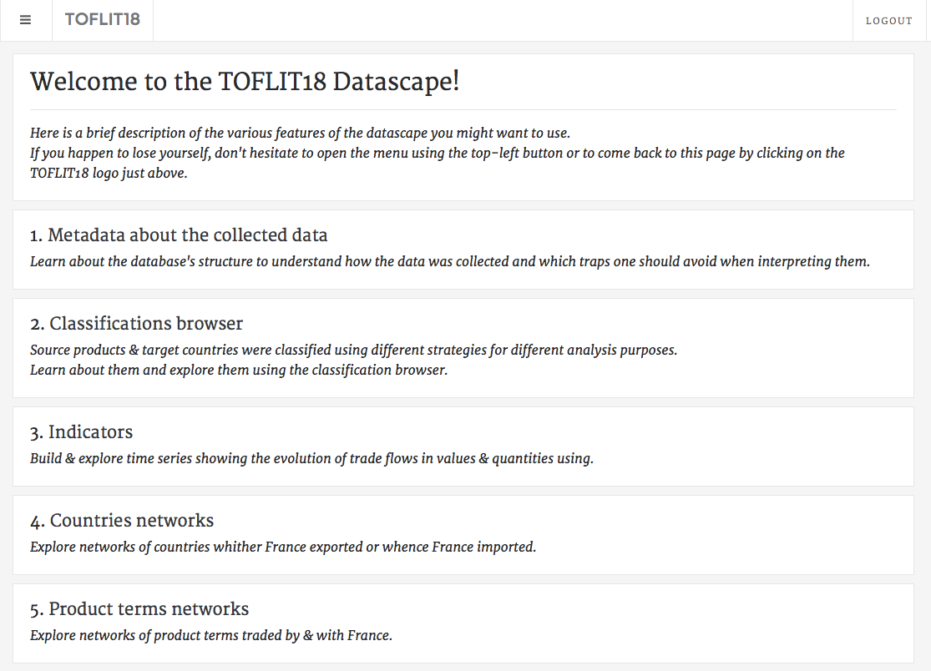

The home page describes the different features of the Datascape you can use. You can come back to the home page at any time by clicking on the toflit18 logo (surrounded in red). All these features will be described below.

1. Metadata about the collected data

By clicking on “Metadata about the collected data”, you can learn some information about the database’s structure and understand data collected.

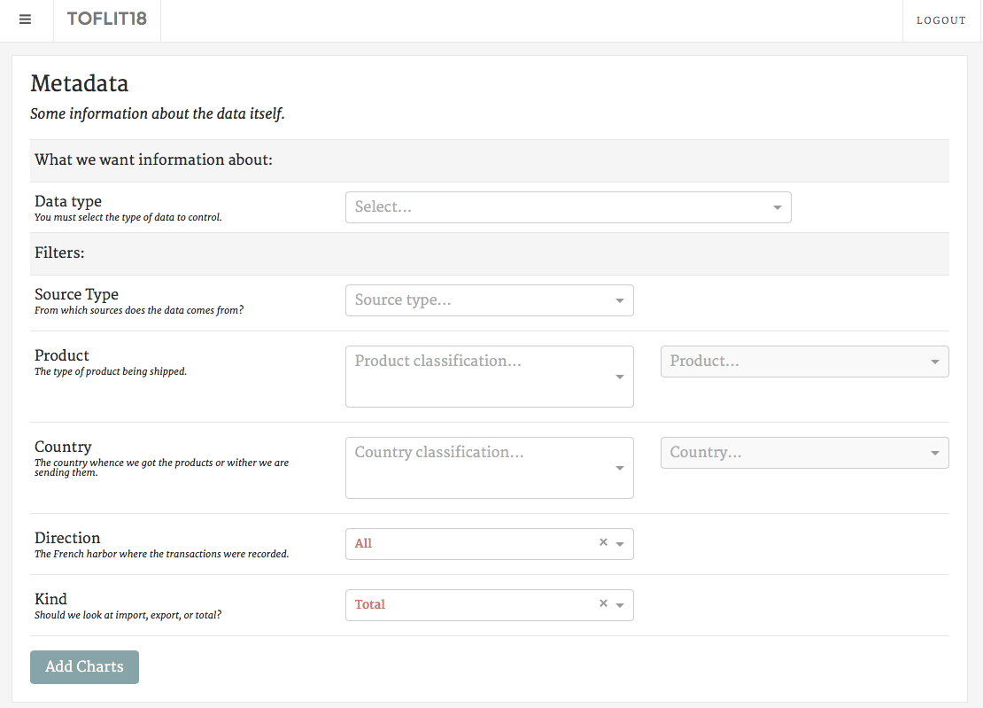

First of all, you need to select the type of data you want information on (“Data type”). There are several types:

* “Direction”: shows all the French regions that provided data, you can see where the data are available.
* “Source type”: shows the types of sources available: national sources, local sources, sources from the colonies, etc…
* Different merchandises’ classifications:

“Sources”, “Orthographic Normalization” and “Simplification” concern the spelling of merchandises (how it is written in the sources, how they were normalized and simplified);

“Medicinal products”, “Hamburg classification”, “North America”, “Eden Treaty”, “Grains”, “SITC”, “SITC EN” and “SITC FR” are several other merchandises’ classifications.  
These types of data show the occurrences (number of flows) of each category of the selected classification for every year.

* Different geographic classifications:

“Sources”, “Orthographic Normalization” and “Simplification” concern the spelling of countries (how it is written in the sources, how they were normalized and simplified);

“Grouping” and “O’Brien” are countries’ classifications.

These types of data show the number of flow of each country or category of the classification selected for every year.

Thus, you can use filters to choose a source type, a category of products (or just a single product), a group of countries (or just a single country), a direction and you can separate exports from imports.

After your choices were made, you may click on the “Add Charts” button to obtain the relevant information.

As an example, if you choose “Direction” as Data type, you will have first the number of directions per year and after that all the different directions with the number of flows for every direction each year.

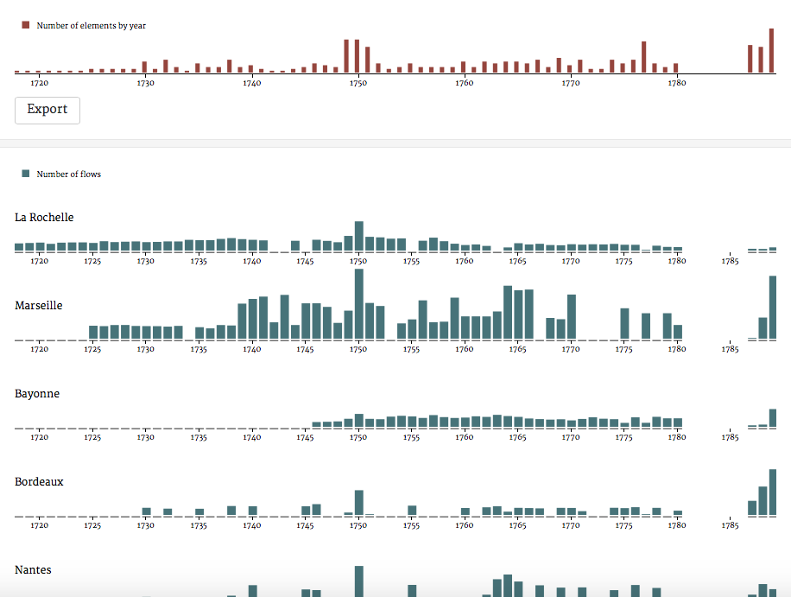

1. Classifications browser

By clicking on “Classifications browser”, you can find all the classifications for products and countries and all the items included in each category of classification.

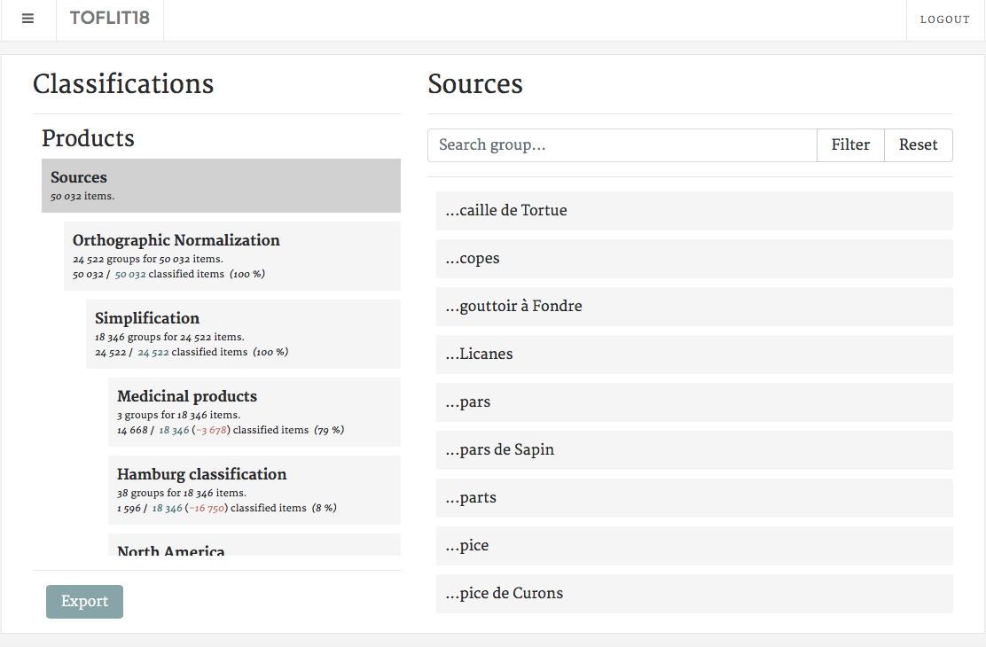

For example, if you want to find out how an item was classified in the SITC (Standard International Trade Classification), click on SITC inside the scroll-down menu on the left and write the name of the item on the area “Search item”. Then, press Enter or click on Filter for the datascape to show you the classification.

E.G.: “Tabac en feuilles” is classified into the category n°1 in the SITC classification.

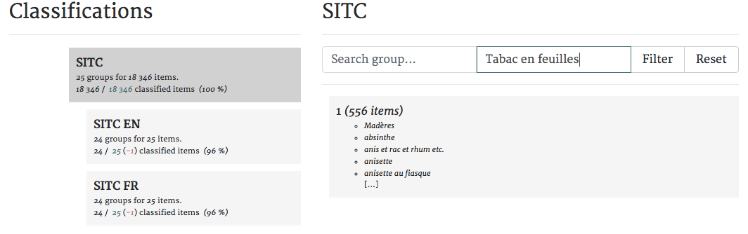

You may select SITC EN to see the details concerning the categories, their meaning, and, for example, understand what category n°1 stands for.

You can also do the same thing with countries’ classification. Sometimes, in the sources, the place indicated is not a country but a city or a region. For example, “Venise” is classified inside “Italie” in the classification Grouping.

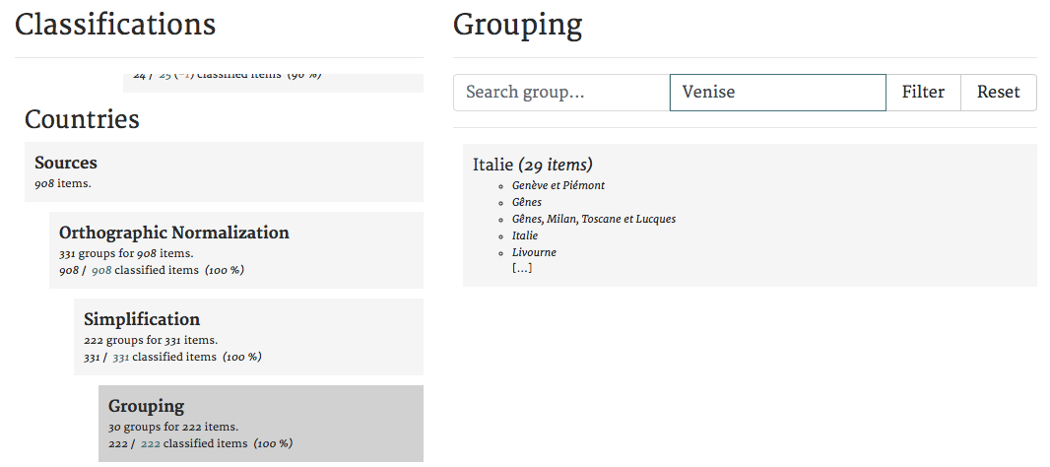

There are several classifications, following a hierarchy described bellow (for example the normalisation and simplification for merchandises, but it is the same work for countries).

Step 1: Orthographic standardization

In order to regroup some merchandises written in different forms in the sources under a same spelling (for exemple : alun, aluns, Alun, ALUN), we have chosen to standardize the spelling of merchandises (in the last example, the good spelling is “alun”). So as to do this standardization, some rules are required to do it properly. You can find all these rules in French in the file “Normalisation et simplification orthographique des marchandises”.

Thanks to this orthographic standardization, the 50 000 merchandises names represent less than 25 000 standardized names. Obviously, it facilitates the work with the data, as an example to follow the evolution of some merchandises trade.

However, different standardizations correspond to the same merchandise so it is useful to do a simplification after that standardization.

Step 2 : Orthographic simplification

Orthographic simplification consists to regroup different merchandises standardized under a same designation **without losing information**. In fact, this simplification has permitted to reduce the number of merchandises to 18 000.

1. Indicators

By clicking on “Indicators”, you can explore the database and discover time series showing the evolution of trade flows. You can see the number of flows and their total value per year, choosing one direction or all, and the number of elements per year by direction.

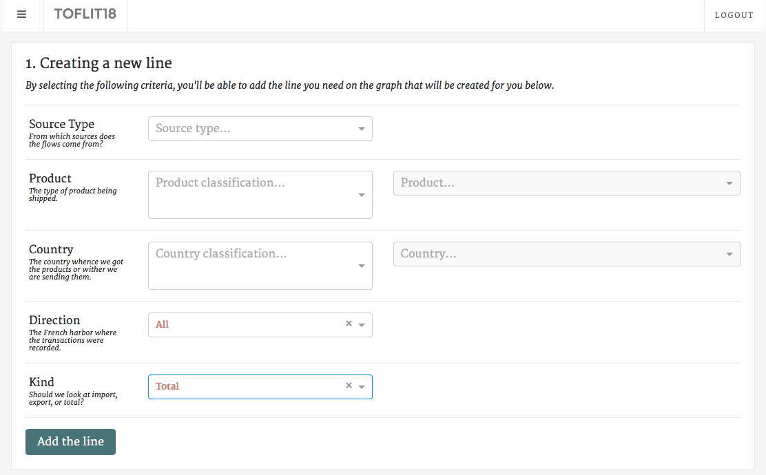

As in the category “Metadata about the collected data”, you can choose which source type you want to keep and which product you would like information on. You can also choose a country with which France has traded, a direction and a kind (Exports or Imports). Then you may click on “Add the line” and explore the results.

Of course, you can fill in none of the criteria, click on “Add the line” and have results about the entire database. As shown in the following example: you can see the number of flows per year and its value from the National best guess sources, and the number of directions per year found in the database for that source type.

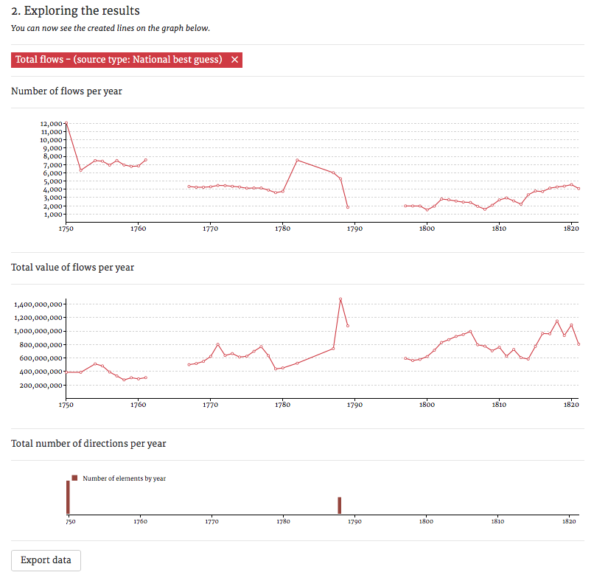

To export the data in text-form, use the “Export data” button on the bottom right of the page.

Additionally, you can compare several time series. For instance, you can compare the evolution of imports and exports in the entire database, you just have to select Imports in the criteria « Kind » and « Add the line »; then you may do the same thing with Exports and both graphs will come on top of each other.

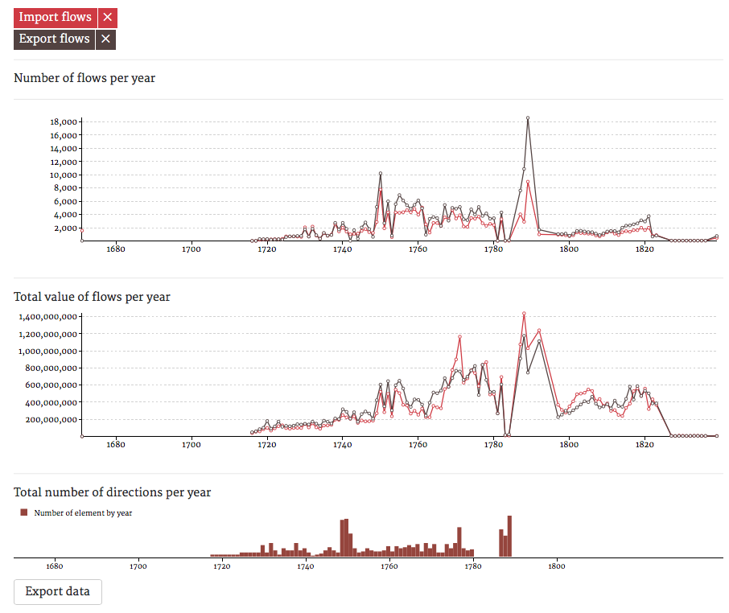

1. Countries network

By clicking on “Countries network”, you can explore relationship between directions and countries, between French regions and their partners.

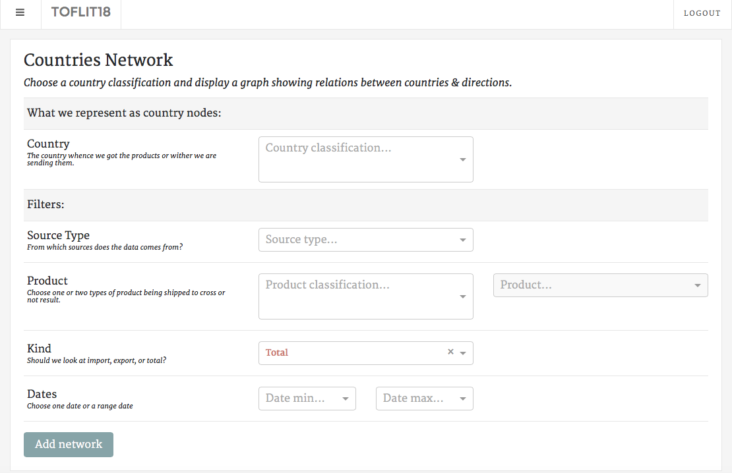

First, you shall select which country classification you wish to work with. Then you might choose filters (even though it is not required to add a network): source type, product, kind (Imports or Exports) and dates.

Thereafter, click on “Add network”, and the graph representing the network you selected will appear. For example, we have chosen “simplification” as country nodes without any filter.

That is what appears on the screen:

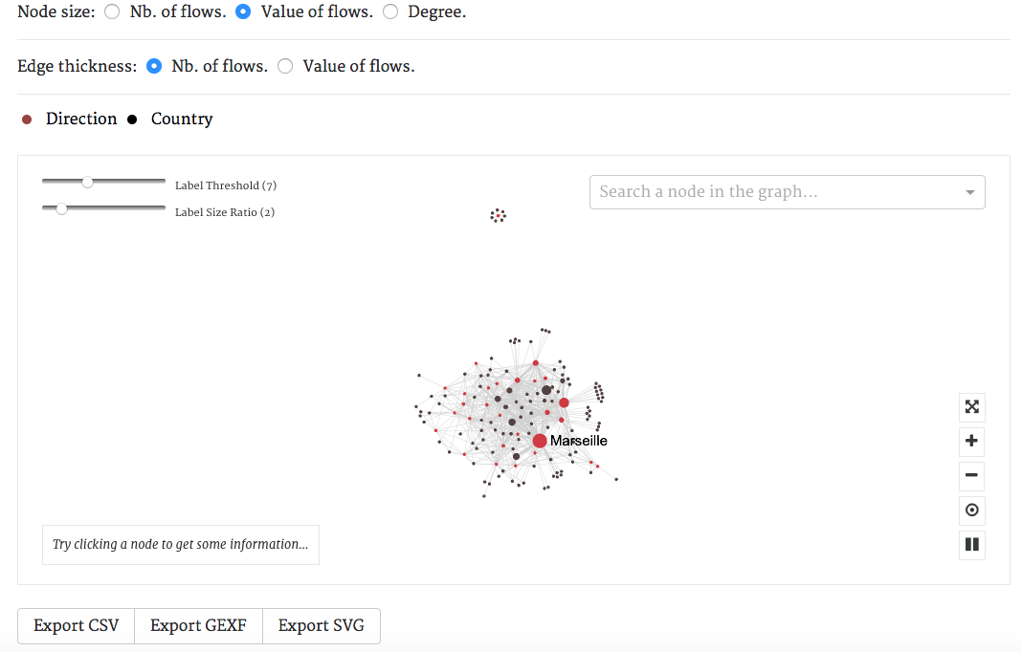

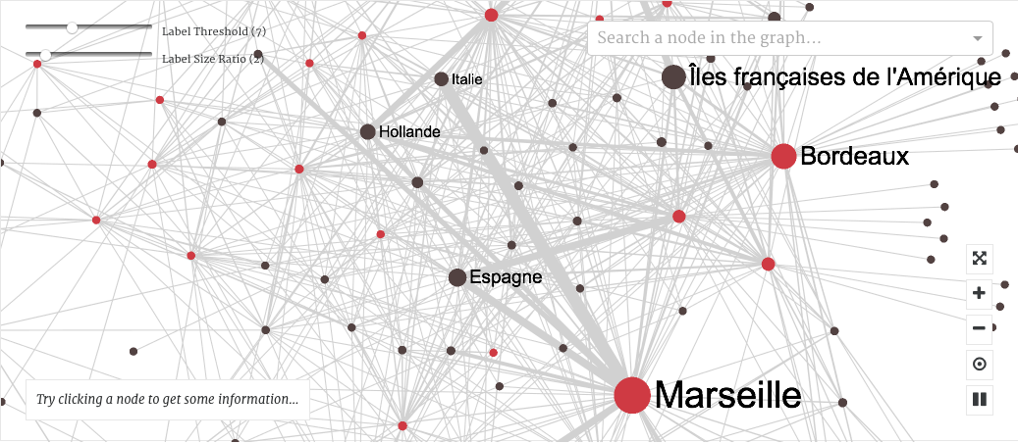

You can see a real network and you can “play” with it. Zoom in if you’d like a better visibility of relationships between directions and countries.

In that interface, you have different possibilities with different buttons:



Put the network representation in full screen

Zoom in or zoom out

Restart the initial representation

Break the representation

Moreover, you can choose if you want the nodes to represent the number of flows between directions and countries, or the value of flows. Thus, the bigger the node is, the higher the number or the value of flows.

You can do the same thing with the links between nodes (choose between number or value of flows).

Furthermore, you can also see more labels of countries and directions by diminishing the label threshold and increase the size of these labels by raising the label size ratio.

Finally, you can search a node in the representation with the tool “Search a node in the graph” and get some information on the country or direction chosen by clicking on a node (you will obtain the number of flows, the value of these flows and the degree).

In order to export your results, you may choose between the following file formats : CSV, GEFX or SVG.

1. Product terms network

By clicking on “Product terms network”, you can explore relationships between product terms traded by and with France. It allows you to see how products terms are related (as an example, the products “feuilles de tabac” and “feuilles de fer” are linked by the term “feuilles”).

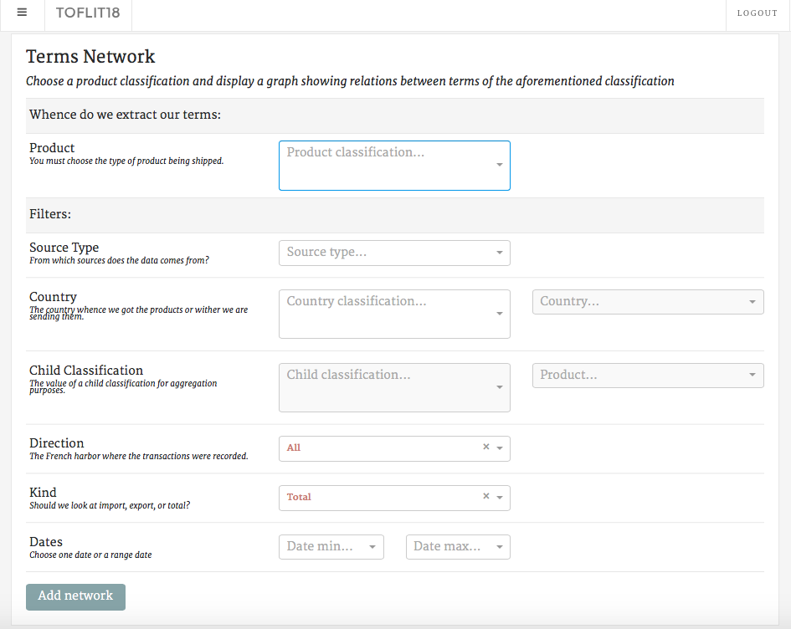

First, you must select which product classification you wish to work on. Then you might choose filters (even though it is not required to add a network): source type, country, direction, kind (Imports or Exports) and dates.

Thereafter, click on “Add network”, and the graph representing the network you selected will appear. For example, we have chosen “simplification” as products nodes with some filters: “simplification” as country, “Bordeaux” as direction and “exports” as kind.

That is what appears on the screen:

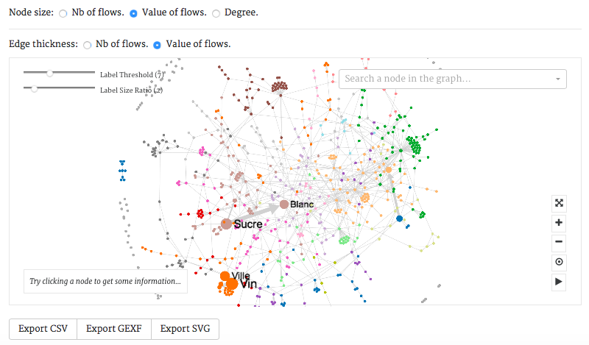

Thus, you can see that the most exported products from Bordeaux are sugar (in particular white sugar, “sucre blanc” in the graph) and vine (in particular town vine, “vin de ville” in the graph).

You can apply the same options that are detailed in “Countries network” except it concerns products, not countries and directions.

By clicking on a node, you will be able to see the number of flows of that product term, its total value and the degree of that term.

FAQ :

Thanks for responding so quickly. Thank you for organizing the event from last week, it was very inspiring and nice to meet you all! I am sorry I could not stay longer. I hope you also had fruitful input for the collective proposal you are working on.  
  
I really like to work with your database, it is awesome! I am sorry if I ask stupid questions, I am not as experienced or well trained in data-handling as I wish I were. However, it is clear that the data from toflit18 can be of great value to my thesis, and I am excited to get to work with it.  
  
As for the data export button: your first advise: to add csv by hand, I tried that in the meantime and it indeed worked, thank you! Unfortunately for me, after that, I met some other error while importing the data in ACCESS but I will seek some local assistance with that – as I think the problem is with the (old) software of my institute.

Great to know that has been solved.

For the second point, right-clicking seems to only provide me with the option to safe the html-page. But it is a minor point. I can fetch all the files from the download folder and rename them – as I need to add .csv anyway, that is no problem.  
  
Some more questions on the data/ data handling:  
  
- You mentioned during the hands-on session that it is necessary to control results for the uneven spread of multiple sources for the data over the years. I have some questions about that. What does your database do in case of multiple source entries for the same flows? Does it just add those up? How do I control for that?

* All sources except « National » « Local » and « National Best Guess » and « Local Best Guess » are « unique», in the sense that the same flow is never reported twice. « National » includes all flows reported at the national level by product and partner. There might be duplicates. « Local includes all flows reported by product, partner and direction. There might be duplicates. « National Best Guess » includes all flows reported at the national level by product and partner, but deals with duplicates by choosing one of them according to a pre-defined rule based on the quality of each source. Idem for « Local Best Guess» for flows reported by product, partner and direction.

- What is exactly the selection of local best and national best? How does it work? Should I combine national and local best guest for the best result? What do you recommend?

See preceding question.

- Also: I see that the Hamburg classification is useful to me. What is the background of this classification? Is there a possibility that I miss some things, when using that category? For example, when I use the sucre – categorie, can I be sure that this really includes all kinds of sugar?

This was done to compare French trade to the North with Hamburg data (and uses Hamburg’s categories). So the answer is «no», because good names that are not present in the North trade are not systematically classified.

- If I see some anomalies I want to investigate deeper, like the coffee peak in 1771 Pierre Gervais brought into attention during the presentation of Torsten Arnold, is it possible to get access to scans of the primary sources on that? Or a level higher- to the original entries?

Yes, we can give you access to all scans.

- Is it also possible to hand-pick all different denominations of sugar, let say in the Bordeaux and Nantes export to Holland – and maybe re-categorize them in a few categories: types of sucre brut – terré and blanc? (The differentiation is important to understand industry- protection policies) That probably means work for you, right?

To do that, you would have to start from a classification and transform it (they are simply .csv files with two columns). Then you can send the classification to us and we will integrate it the datascape.  
We are working on including a less-circuitous way of doing it, but it will not be as flexible as this latter option.  
Once the classification is done, it is pretty easy for us to integrate it. Doing the classification is no fun, but I can give you a .csv file with good names implied in specific trade routes pretty easily, which should reduce the work you have to do.

I will first see how far I come with the Hamburg-categories and the export-button. This already provides me with more data than I had gathered so far on Dutch colonial imports from France. I am so lucky your project finished within the time I had for my Ph.D!